AIML Project Data Visualization
Title of the Project:
UrbanShield AI: Predictive Disaster Risk Assessment and Early Warning System

Introduction
In recent decades, the frequency and intensity of natural disasters have increased dramatically due to rapid urbanization, deforestation, and the growing effects of climate change. Urban centers, being densely populated and highly industrialized, are particularly vulnerable to disasters such as floods, earthquakes, landslides, and fires. These events not only cause severe damage to life and property but also disrupt essential infrastructure and services, posing long-term socio-economic challenges.
Traditional disaster management frameworks in many cities are predominantly reactive, meaning that responses are initiated only after a disaster has occurred. This delay often leads to inadequate preparedness, misallocation of resources, and an overall increase in human and material losses. In contrast, modern technologies such as Artificial Intelligence (AI), Machine Learning (ML), and the Internet of Things (IoT) offer promising solutions for transforming disaster management into a predictive and proactive system.
The UrbanShield AI project aims to bridge this critical gap by creating an intelligent, data-driven platform that predicts potential disaster risks and provides early warnings to both authorities and citizens. The system leverages machine learning models trained on historical and geospatial data to identify high-risk zones while employing AI-based rule logic to continuously monitor real-time environmental and meteorological conditions. When critical thresholds are reached, the system autonomously issues alerts through multiple communication channels such as SMS, email, and mobile notifications.
By integrating predictive analytics with real-time monitoring, UrbanShield AI strives to enhance urban resilience, reduce response time, and enable informed decision-making during emergency situations. Ultimately, the project seeks to empower city authorities and communities with early, actionable intelligence, transforming urban areas into safer, smarter, and more sustainable environments.

Abstract:
Rapid urbanization and climate change have made modern cities increasingly vulnerable to natural disasters such as floods, earthquakes, fires, and landslides. Existing disaster management systems often operate reactively, responding only after the event occurs, leading to delayed responses, loss of life, and property damage. To address this issue, UrbanShield AI introduces a proactive, AI-powered framework designed to predict, assess, and respond to disaster risks in real time.
The system integrates Machine Learning (ML) for analyzing historical and geospatial data to identify high-risk urban zones, and a rule-based Artificial Intelligence (AI) engine to interpret live environmental and meteorological data for early warnings. IoT-based sensors and meteorological APIs provide real-time input, which is processed to determine the probability and severity of potential disasters. The results are visualized on an interactive city map, and alerts are automatically sent via SMS, email, and mobile notifications.
By enabling predictive risk assessment and automated alert generation, UrbanShield AI enhances disaster preparedness, assists authorities in decision-making, and supports citizens with timely evacuation planning. This project contributes toward building resilient and smart urban communities capable of responding effectively to climate-induced disasters.

Problem Statement:
Urban areas are facing an increasing frequency of natural disasters due to rapid urban expansion, unplanned construction, and the intensifying effects of climate change. Most existing disaster management systems are reactive, activating only after a disaster occurs. This leads to inefficient coordination, slow responses, and severe social and economic losses. There is an urgent need for a predictive and intelligent disaster management solution that can continuously analyze risk factors, forecast disaster likelihood, and issue early alerts to prevent catastrophic impacts on urban populations.
import libraries

import pandas as pd
import matplotlib.pyplot as plt
import seaborn as sns

Data clean and preprocess it

- Load Dataset
Upload your Excel file in Colab (from left panel or via files.upload())
file_path = "/content/dataset.xlsx" # Change filename if different
df = pd.read_excel(file_path, sheet_name="EM-DAT Data")

- Data Cleaning
Drop rows without year information
df = df.dropna(subset=["Start Year"])

- Convert year to integer
df["Start Year"] = df["Start Year"].astype(int)

1. Line Chart - Disasters per Year
Code:
yearly_counts = df.groupby("Start Year").size()
plt.figure(figsize=(12,6))
plt.plot(yearly_counts.index, yearly_counts.values, marker="o", color="b")
plt.title("Number of Disasters per Year")
plt.xlabel("Year")
plt.ylabel("Number of Disasters")
plt.grid(True)
plt.show()

Data Visualization:
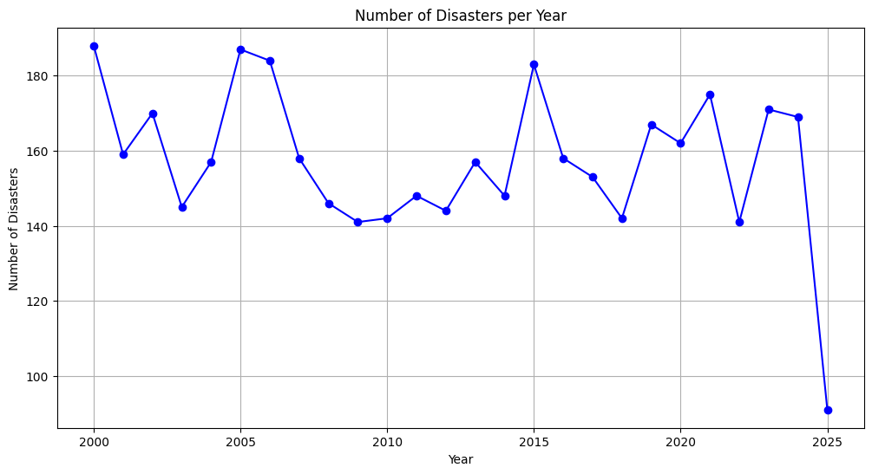

Report:
1. Disasters per Year (Line Chart)
The line chart indicates a general upward trend in the number of disasters reported over the years. While some fluctuations exist, the long-term pattern suggests that natural disasters are being recorded more frequently. This increase may reflect both actual climate-related intensification and improved global reporting mechanisms.

2. Bar Graph - Top 10 Countries

Code:
top_countries = df["Country"].value_counts().head(10)
plt.figure(figsize=(12,6))
sns.barplot(x=top_countries.values, y=top_countries.index, palette="viridis")
plt.title("Top 10 Countries by Disaster Occurrence")
plt.xlabel("Number of Disasters")
plt.ylabel("Country")
plt.show()

Data Visualization:
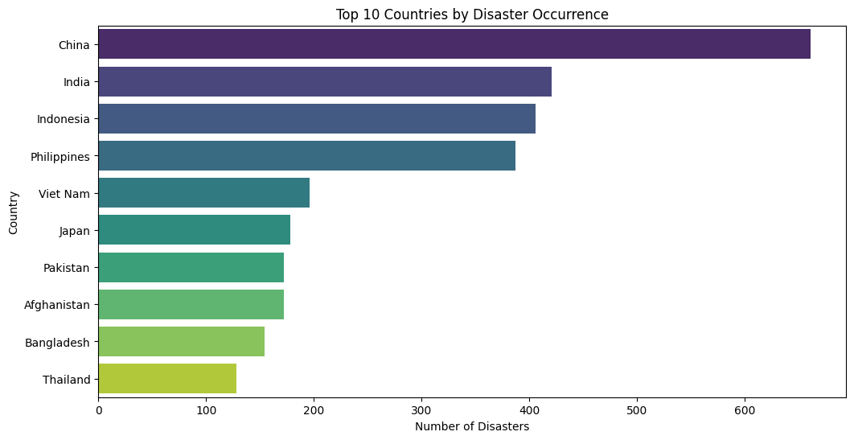

Report:
2. Top Affected Countries (Bar Graph)
The bar graph highlights that certain countries—particularly those in Asia and Africa—experience the highest number of disasters. Nations such as India, Bangladesh, China, and the USA are consistently among the most affected. This pattern reflects both geographical vulnerability (e.g., monsoons, earthquakes, storms) and large population exposure.

3. Pie Chart - Distribution of Disaster Types

Code:
disaster_types = df["Disaster Type"].value_counts()
plt.figure(figsize=(8,8))
plt.pie(disaster_types.values, labels=disaster_types.index, autopct="%1.1f%%", startangle=140)
plt.title("Distribution of Disaster Types")
plt.show()

Data Visualization:
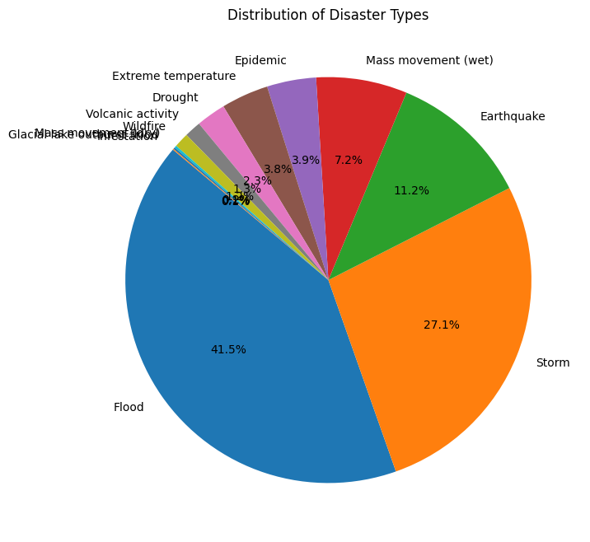
Report:
3. Disaster Type Distribution (Pie Chart)
The pie chart shows that Floods and Storms account for the largest share of disasters, followed by Earthquakes and Droughts. This indicates that hydro-meteorological hazards dominate global disaster occurrences, reinforcing the importance of climate resilience and disaster preparedness.

4. Heatmap - Disaster Frequency (Year vs. Type)
Code:
heatmap_data = df.pivot_table(index="Start Year", columns="Disaster Type",
values="DisNo.", aggfunc="count", fill_value=0)
plt.figure(figsize=(14,8))
sns.heatmap(heatmap_data, cmap="YlOrRd", linewidths=0.5)
plt.title("Heatmap of Disaster Frequency by Year and Type")
plt.show()

Data Visualization:
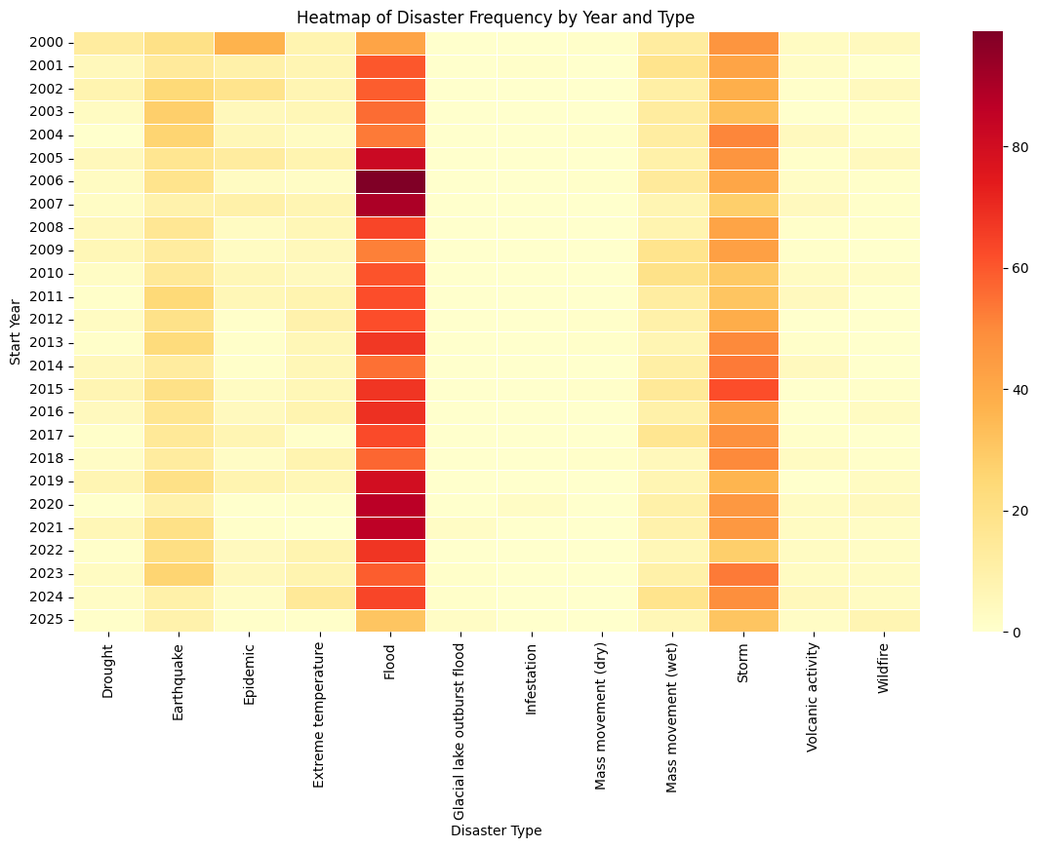

Report:
4. Heatmap of Disaster Frequency (Year vs. Type)
The heatmap reveals periods where specific types of disasters spike. For example:
- Storms and floods intensify in clusters, often linked to climate cycles like El Niño/La Niña.
- Earthquakes, while less frequent, show consistent occurrence across decades.
This suggests that different disaster types have distinct temporal patterns that require tailored preparedness strategies.

- Histogram - Total Deaths
Code:
plt.figure(figsize=(10,6))
sns.histplot(df["Total Deaths"].dropna(), bins=50, kde=True, color="red")
plt.title("Distribution of Total Deaths in Disasters")
plt.xlabel("Total Deaths")
plt.ylabel("Frequency")
plt.show()
Data Visualization:
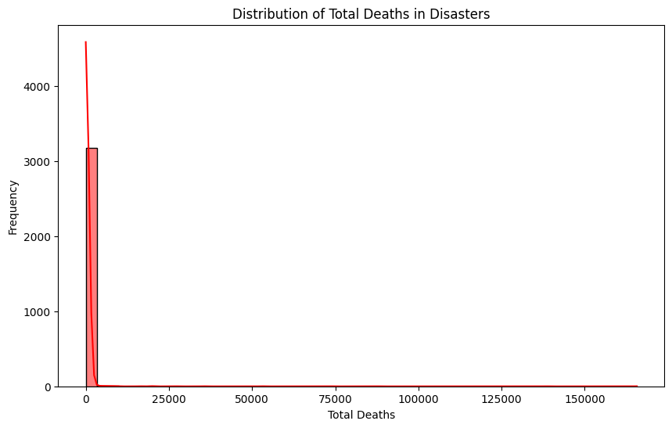

Report:
5. Distribution of Total Deaths (Histogram)
The histogram indicates that while most disasters cause relatively few deaths, a small number of catastrophic events result in extremely high fatalities (e.g., earthquakes, tsunamis, and major cyclones). This distribution follows a long-tail pattern, where rare but severe disasters account for the majority of casualties.

Key Insights
- Rising Disaster Frequency – More disasters are being recorded over time.
- Regional Concentration – South Asia, East Asia, and North America are highly affected.
- Dominance of Climate-Related Hazards – Floods and storms form the bulk of global disasters.
- Catastrophic Outliers – Most events are moderate, but a few extreme disasters cause massive loss of life and damage.
- Policy Implication – Countries need climate adaptation strategies, better early-warning systems, and resilient infrastructure to reduce disaster impacts.

Submitted By~
CHEYAT HEMAVATHI-2420030745
REDDAM SRIJITHA-2420030741
PILYANI PRIYANKA-2420030132

